**Science in Golden Cheetah**

Wherever possible we choose to use published science. Science that has been developed with the academic rigour demanded by the scientific method; evidence based, peer-reviewed and original. This means we are able to provide the best analysis available, but at the cost of a steep learning curve for new users. So below, we try to introduce some of the most important concepts and how they help you improve.

**Power and Duration - Critical Power and W’**

How hard can you go, in watts, for half an hour is going to be very different to how hard you can go for say, 20 seconds. And then thinking about how hard you can go for a very long time will be different again. But when it comes to reviewing and tracking changes in your performance and planning future workouts you quickly realise how useful it is to have a good understanding of your own limits.

In 1965 two scientists Monod and Scherrer presented a ‘Critical Power Model’ where the Critical Power of a muscle is defined as ‘the maximum rate of work that it can keep up for a very long time without fatigue’. They also proposed an ‘energy store’ (later to be termed W’) that represented a finite amount of work that could be done above that Critical Power.

***The Critical Power Model***

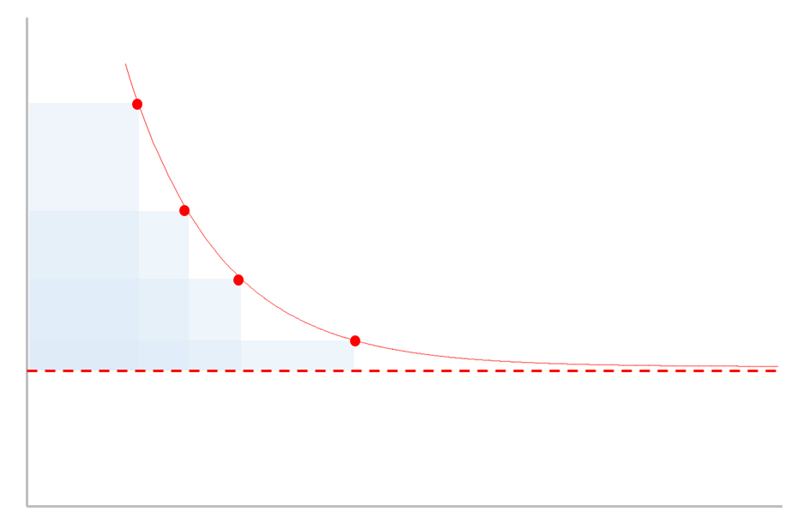

work

In cycling parlance W’ would be referred to as the matchbook– the harder you go the quicker it will be used up, but temper your efforts and you can ‘save a match’ for the last sprint. CP, on the other hand, is that intensity (or power output) where you are uncomfortable but stable, akin to your TT pace. You know that if you try to go any harder you are gonna blow up pretty quickly.

time

W’

CP

Monod and Scherrer also provided a mathematical formula to estimate the maximum power you can go for any given duration using W’ and CP as parameters. This formula is pretty reliable for durations between 2 and 20 minutes or so, but less so over short and longer durations. And so, over the last 50 years, variations of these models have been developed to address this, and it continues to be a topic of great scientific interest.

We have implemented some of these models so you can get power estimates to predict and review your training and racing.

**Analysing Power Data – Average, xPower and NP**

When you first start using a power meter you notice that power tends to move around a lot more than, say, your heart-rate.

When you stop pedalling power drops to zero immediately, but HR may take 30 seconds or so to recover. In truth, although the power meter says zero watts when you stop, the body’s physiological response continues for roughly 30 seconds, as HR drops, breathing recovers and more complex energy system processes continue.

This means that if we want to use power output as a measure of training stress we will also need to translate those simplistic power readings into something that reflects the associated physiological processes and their half-lives.

This is what Dr Andrew Coggan’s Normalised Power and Dr Phil Skiba’s xPower are doing; they ‘smooth out’ the power data to reflect the underlying physiological processes. Whilst the underlying assumptions and maths differ slightly they both yield a power output that will reflect the stress of the variable power values more accurately than just taking a simple average.

**Skiba/Literature Coggan/TrainingPeaks**

|  |  |
| --- | --- |
| Variability Index | Variability Index |
| Relative Intensity | Intensity Factor |
| xPower | Normalised Power |
| BikeScore  Critical Power  W’  W’bal | Training Stress Score  Functional Threshold Power  Functional Reserve Capacity  dFRC |

**Quantifying Stress – Work, Intensity, TSS and TISS**

Given that work in joules can be calculated by multiplying power by time it is very tempting to use this to measure the stress of a ride. But as we get stronger and more efficient those joules become easier to produce, and thus the training stress accrued in the workout should reflect that.

To account for this we need some kind of score that takes into account how hard the ride is based upon our current capability. This is precisely what BikeScore and TSS do. They reflect the stress by taking into account the relative intensity of the workout. This intensity factor is computed as a ratio of the xPower to our current CP. This intensity is then multiplied by the ride duration to get an overall stress score; the higher the stress score the bigger impact it will have had and likely the more recovery we will need the day after.

But there is still a problem, we know that work at high intensities for short durations elicits a different strain to work at low intensities for longer durations and there comes a point where more pain will give little gain. To counter this Dr Skiba introduced Ae and An TISS that are weighted differently for low and high intensity work and allow us to track these training stresses separately.

**Matches and Pacing – W’bal**

Unless we’re riding the pursuit or a very flat time trial, when we train and race we tend to ride sustained efforts interspersed with recovery. These intermittent bouts might occur when we climb a hill, or sprint out of a corner or bridge a gap. In fact almost all training and racing away from the turbo tends to be variable because of this.

Now, we know from the Critical Power model that when we work above CP we start eating into our limited W’ stores. If we keep going hard enough for long enough we will blow when it’s all gone. But, we also know that it will also be replenished over time too.

**W’bal in an evenly paced 2x20 Workout**

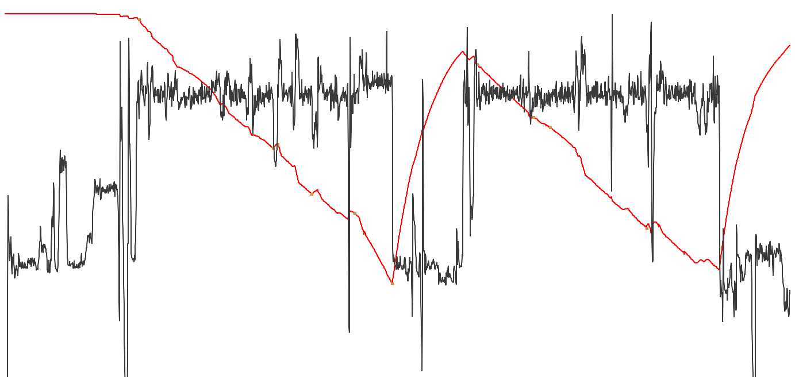

When we work below CP the energy stores within the muscles are restocked. The further below CP we are the faster we will recover, and for the first 30 seconds of recovery we get the most bang for buck as blood-flow into the muscles is still high from the previous bout

Dr Skiba provided a formula for tracking the levels of W’, called W’bal that we can plot alongside power.

It is particularly useful for assessing workouts for likely failure and reviewing and comparing intervals within a single workout, even when they are of differing durations.

It is likely that in the near future you will see W’bal appear on bike computer headunits to show you the capacity remaining as you race.

**Bioenergetics**

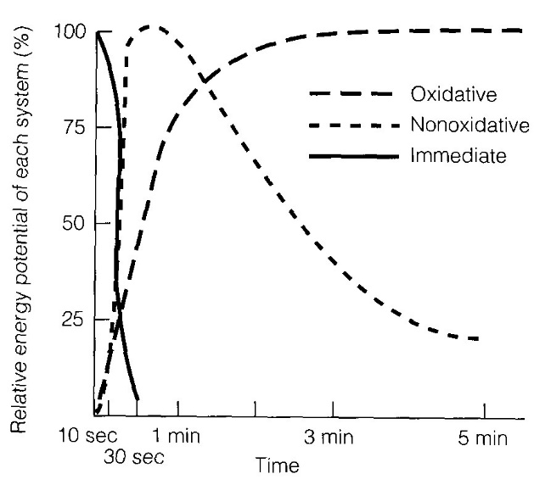We use complex sources of overlapping energy when we exercise. These energy sources are; anaerobic and have a limited capacity and a high rate limit (like W’), aerobic and have unlimited capacity but a low rate limit (like CP).

**Anaerobic Systems** In the first 10 seconds or so of high output work we draw immediately upon energy stored within the muscles with immediate availability – so we can sprint all out for 10-30 seconds without drawing breath and at very high work rates ! The chemicals stored in our muscles are **ATP** (adenosine triphosphate) and **PCr** (phosphorcreatine).Interestingly, after about 3 minutes of total rest these stores are largely replenished.

So for the next 50 seconds or so after those phosphates are depleted we primarily get our energy from **glycolysis** and still without drawing breath!This is the conversion of glucose into lactate. It takes us about 1 hr to recover and remove all the lactic acid produced, but most of it is gone after about 10 minutes – and we can speed up this clearance through light exercise – which is why a warm-down is a good idea after intense exercise.

**Aerobic Systems** But now, sadly, after that first all out minute we are going to have to draw breath, because we need the oxygen to power the aerobic energy systems. First up we get **aerobic glycolysis**, this is converting glucose into citric acid by burning it with oxygen in a really complicated 10 stage cycle. The rate is limited by the amount of oxygen the lungs can absorb (vo2max) and the available fuels. It can take 1-3 minutes to get up to ‘peak’ production and then dies away slowly over time once all the glucose is gone, we will bonk.

And then lastly, from about 6-7 minutes we start to rely upon **lipolysis** that utilises an almost limitless source of energy, fat.

**The Extended Power Duration Model**

The Extended Power Duration Model extracts the likely contribution of these energy systems to predict the energy production (or watts per second). This is akin to reading the fuel gauge to work out how fast you’re going in a car. It’s not an exact science and so yields an approximated answer. Most modern PD models are based upon bioenergetics, it is likely that in the next 2-3 years the focus will switch to muscular and psychological fatigue and constraints that will likely reduce the often *slightly overestimated* values yielded by bioenergetics models.